<https://learn.deeplearning.ai/courses/langchain/lesson/1/introduction>

**LangChain for LLM Application Development**

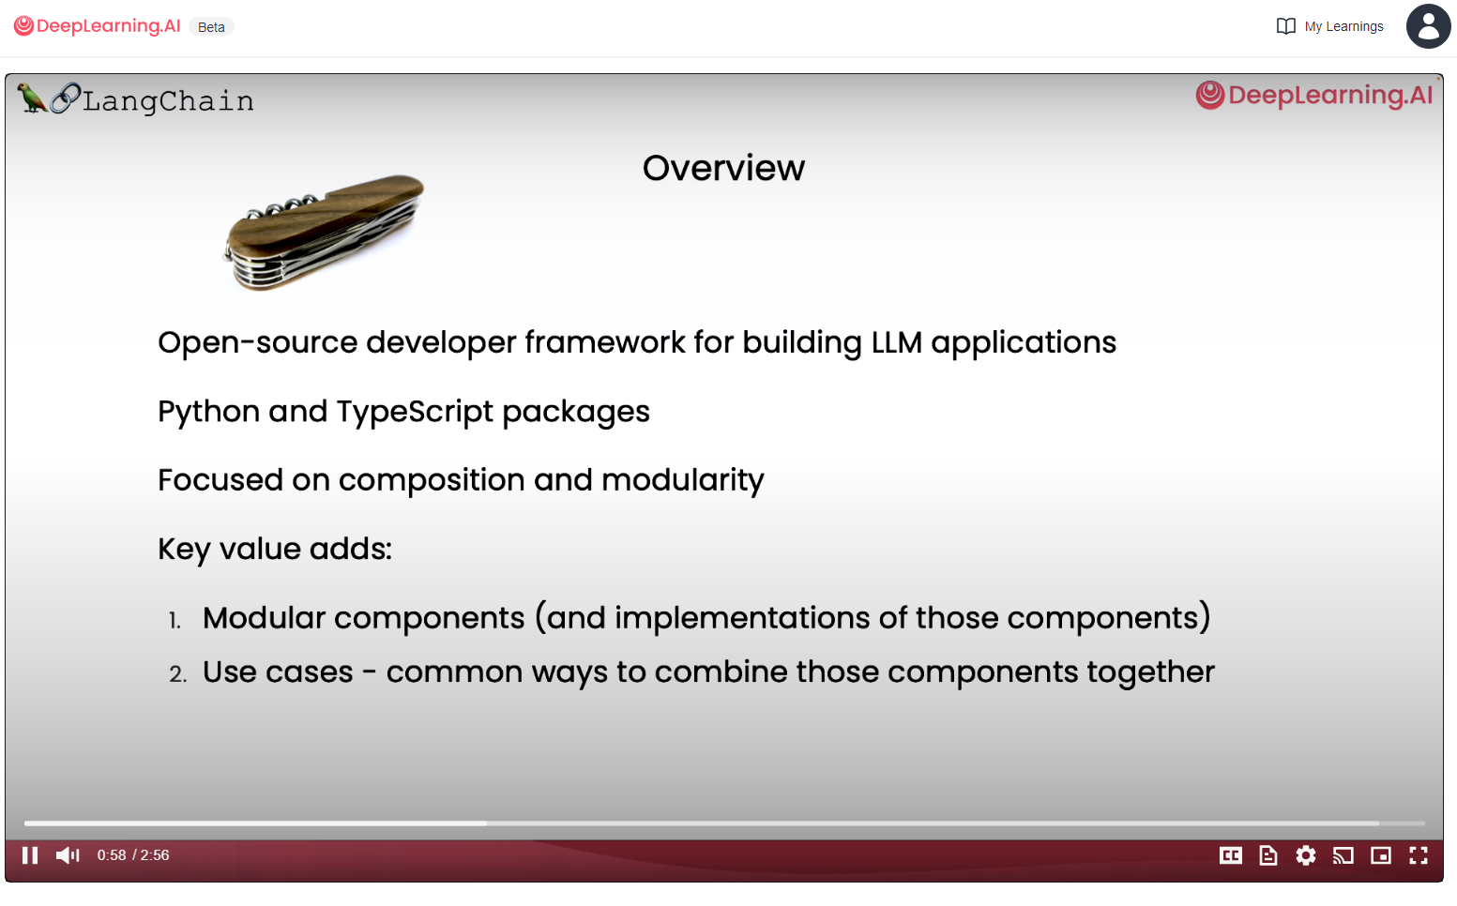

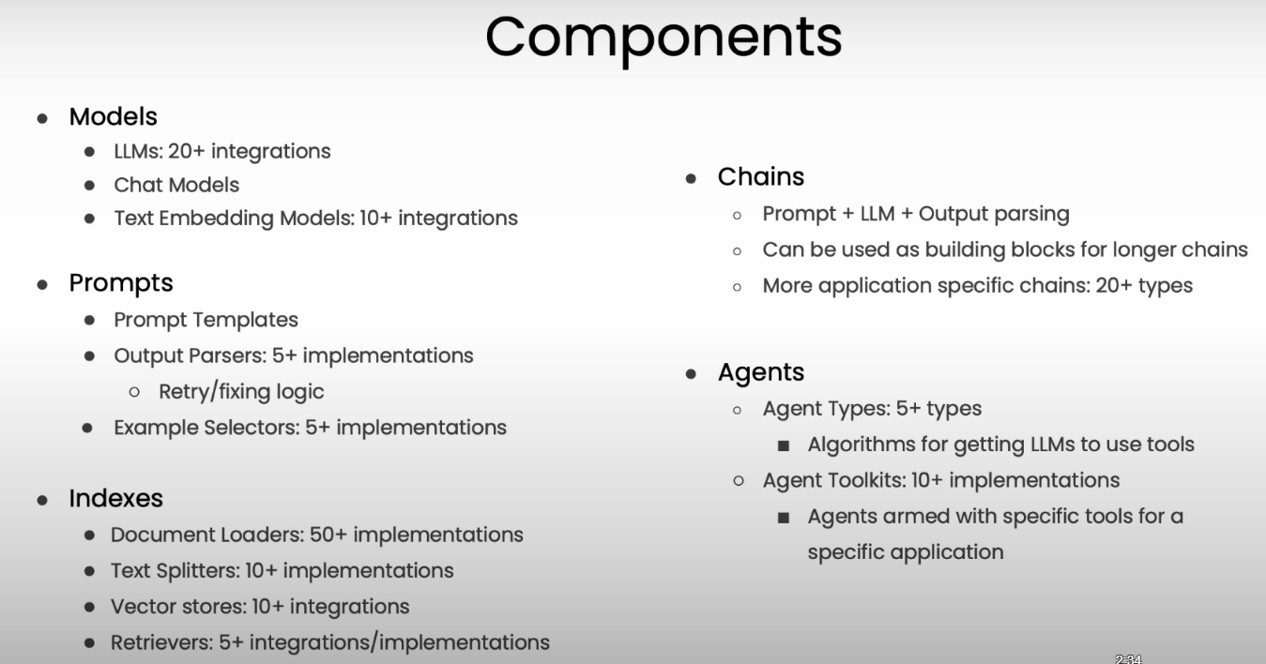

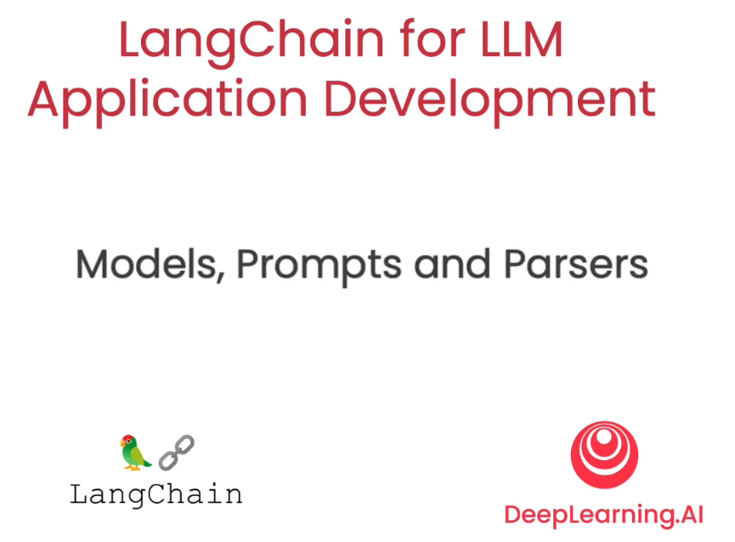

Model – Language Model

Prompts- the style of creating input to pass into the model

Parsers – are at the opposite end – they take output from the model and parse it into more structured format (so we can do things downstream with it)

